# CS 255 System Design Document Template

This template lays out all the different sections that you need to complete for Project Two. Each section has guidance to prompt your thinking. You will need to continually reference the interview transcript as you work to make sure that you are addressing your client’s needs. There is no required length for the final document. Instead the goal is to complete each section based on what your client’s needs are. Remove this note when you are finished, and replace all bracketed text with the relevant information.

## UML Diagrams

### UML Use Case Diagram

### UML Activity Diagrams

### UML Sequence Diagram

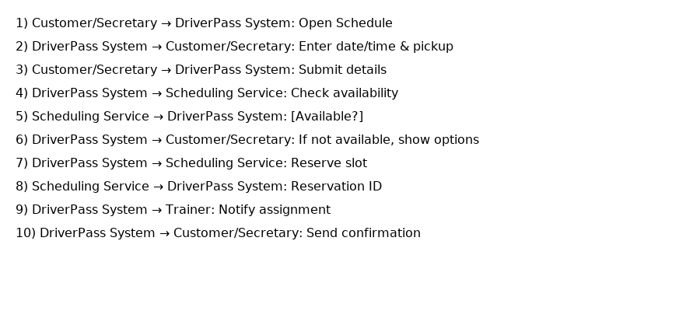

### UML Class Diagram

## Technical Requirements

*The DriverPass system will be set up as a website that works on any modern computer, tablet, or phone. Customers and trainers just need a device with internet access to use it. For staff in the office, a regular computer with at least 8 GB of memory and good internet service will be enough to handle daily tasks like scheduling and customer support.*

*The system will use a database to keep track of customers, lessons, trainers, cars, and test results. It will run in a web browser, so nothing special needs to be installed by users. The website will also use secure connections (HTTPS) so that all information stays private when it is sent or received.*

*The company will host the system online using a reliable cloud service so it can be backed up often and continue to run smoothly if something goes wrong. Backups will make sure no important data is lost, and the system can be restored quickly if needed. The cloud setup will also let the system grow to handle more users over time.*

*To keep information safe, each type of user, like customers, trainers, and administrators—will have their own login with different levels of access. All passwords will be protected, and sensitive data will be kept secure. If the system processes payments, it will connect to a trusted payment service so card details are never stored directly in the system.*

*Finally, the system will include simple reports that show information such as reservations, cancellations, and student progress. These reports can also be downloaded so staff can review them outside the system if needed. This setup will keep the DriverPass program reliable, easy to use, and secure for both customers and employees.*